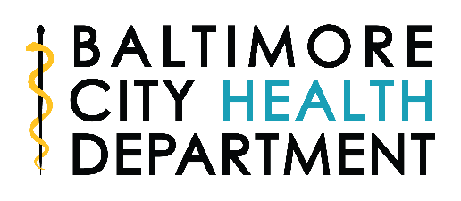

REQUEST FOR ASTHMA WORKSHOP

Fax this completed form to: (410) 244-1366

Attention: Magaly Burgess Date: ____/____/_____

Baltimore City Community-Based Asthma Education:

Contact Person___________________________ Phone #___________________

Email address: ______________________________________________________

Organization: ______________________________________________________

Address: ___________________________________________________________

Expected # of Attendees _____________Target Audience ___________________

The workshop will be conducted in: English ______ Spanish_______

The Baltimore City Health Department provides
FREE workshops
in English or Spanish
for parents and caregivers of
children with asthma

Topics covered include:
- Asthma symptoms and symptom prevention
- Identification and reduction of asthma triggers
- Talking with your provider
- Sharing concerns about caring for a child with asthma
- Or tailored to your audience

